Question one
JAVA IMPLEMENTATION SOURCE CODES
Book.java
public class Book {
private String isbn;
private String title;
private String author;
private boolean available;
// Constructor 1
public Book (String isbn, String title) {
this.isbn = isbn;
this.title = title;
this.author = "Unknown Author";
this.available = true;
}
// Constructor 2 (Overloaded)
public Book(String isbn, String title, String author) {
this.isbn = isbn;
this.title = title;
this.author = author;
this.available = true;
}
// Getters and Setters
public String getIsbn() { return isbn; }
public void setIsbn(String isbn) { this.isbn = isbn; }

public String getTitle() { return title;}
public void setTitle(String title) { this.title = title; }

public String getAuthor() { return author; }
public void setAuthor (String author) {this. author = author; }

public boolean is Available () {return available; }
public void setAvailable(boolean available) { this.available = available; }

@Override
public String to String() {
return "Book [ISBN=" + isbn + ", Title='" + title + "', Author='" + author + "', Available=" + available + "]";
}
}
Loan.java
import java.time.LocalDate;
public class Loan {
private Member member;
private Book book;
private LocalDate borrowDate;
private LocalDate dueDate;

public Loan(Member member, Book book, LocalDate borrowDate, LocalDate dueDate) {
this.member = member;
this.book = book;
this.borrowDate = borrowDate;
this.dueDate = dueDate;
}

public Member getMember() { return member; }
public Book getBook() { return book; }
public LocalDate getBorrowDate() { return borrowDate; }
public LocalDate getDueDate() { return dueDate; }

@Override
public String toString() {
return "Loan [Member=" + member.getName() + ", Book='" + book.getTitle() + "', Borrowed=" + borrowDate + ", Due=" + dueDate + "]";
}
}
Member.java
import java.util.ArrayList;
import java.util.List;

public class Member {

private String memberId;
private String name;
private List<Loan> loans;

public Member(String memberId, String name) {
this.memberId = memberId;
this.name = name;
this.loans = new ArrayList<>();
}

public String getMemberId() {
return memberId;
}

public void setMemberId(String memberId) {
this.memberId = memberId;
}

public String getName() {
return name;
}

public void setName(String name) {
this.name = name;
}

public List<Loan> getLoans() {
return loans;
}

public void addLoan(Loan loan) {
loans.add(loan);
}

public void removeLoan(Loan loan) {
loans.remove(loan);
}

@Override
public String toString() {
return "Member [ID=" + memberId +
", Name='" + name +
"', Active Loans=" +
loans.size() + "]";
}
}
Library.java
import java.time.LocalDate;
import java.util.ArrayList;
import java.util.List;

public class Library {
private List<Book> books;
private List<Member> members;
private List<Loan> activeLoans;

public Library() {
this.books = new ArrayList<>();
this.members = new ArrayList<>();
this.activeLoans = new ArrayList<>();
}

public void addBook(Book book) {
books.add(book);
}

public void registerMember(Member member) {
members.add(member);
}

public boolean lendBook(String memberId, String isbn) {
Member targetMember = null;
for (Member m : members) {
if (m.getMemberId().equals(memberId)) {
targetMember = M;
break;
}
}

Book targetBook = null;
for (Book b : books) {
if (b.getIsbn().equals(isbn)) {
targetBook = b;
break;
}
}

if (targetMember == null || targetBook == null) {
System.out.println(">>> Error: Invalid Member ID or ISBN reference.");
return false;
}

// Business Rule Enforcement
if (!targetBook.isAvailable()) {
System.out.println(">>> Transaction Rejected: '" + targetBook.getTitle() + "' is already currently out on loan!");
return false;
}

targetBook.setAvailable(false);
LocalDate borrowDate = LocalDate.now();
LocalDate dueDate = borrowDate.plusDays(14); // 2-week loan limit

Loan newLoan = new Loan(targetMember, targetBook, borrowDate, dueDate);
activeLoans.add(newLoan);
targetMember.addLoan(newLoan);

System.out.println(">>> Success: '" + targetBook.getTitle() + "' successfully lent to " + targetMember.getName());
return true;
}

public boolean returnBook(String isbn) {
Loan targetLoan = null;
for (Loan loan : activeLoans) {
if (loan.getBook().getIsbn().equals(isbn)) {
targetLoan = loan;
break;
}
}

if (targetLoan == null) {
System.out.println(">>> Error: No active loan found matching ISBN " + isbn);
return false;
}

targetLoan.getBook().setAvailable(true);
targetLoan.getMember().removeLoan(targetLoan);
activeLoans.remove(targetLoan);

System.out.println(">>> Success: '" + targetLoan.getBook().getTitle() + "' has been safely returned.");
return true;
}

public List<Book> searchBookByTitle(String title) {
List<Book> results = new ArrayList<>();
for (Book b : books) {
if (b.getTitle().toLowerCase().contains(title.toLowerCase())) {
results.add(b);
}
}
return results;
}

@Override
public String toString() {
return "Library State:\n Total Books Registered: " + books.size() +
"\n Total Members Registered: " + members.size() +
"\n Active Outbound Loans: " + activeLoans.size();
}
}
LibraryDemo.java
public class LibraryDemo {
public static void main(String[] args) {
Library library = new Library();

// 1. Create at least two members and three books
Member m1 = new Member("M001", "Bugoma Samson");
Member m2 = new Member("M002", "Kasadha Isaac");
library.registerMember(M1);
library.registerMember(M2);

Book b1 = new Book("978-1", "Introduction to Optics", "Master Kalema");
Book b2 = new Book("978-2", "Respiration"); // Overloaded short constructor
Book b3 = new Book("978-3", "UML Biological science Guide", "Lawrence");
library.addBook(b1);
library.addBook(b2);
library.addBook(b3);

System.out.println("=== INITIAL STATE ===");
System.out.println(library);
System.out.println("=====================\n");

// 2. Perform a sequence of successful lend operations
library.lendBook("M001", "978-1");
library.lendBook("M002", "978-2");

System.out.println("\n--- Attemping rule validation violation checking ---");
// 3. Attempt operation that must be gracefully rejected (Lending an already lent book)
library.lendBook("M002", "978-1");

System.out.println("\n--- Processing Return ---");
// 4. Return processing
library.returnBook("978-1");

System.out.println("\n--- Retrying previously rejected operation after return ---");
library.lendBook("M002", "978-1");

System.out.println("\n=== FINAL STATE ===");
System.out.println(library);
System.out.println("===================");
}
}
Screen shoot of the output
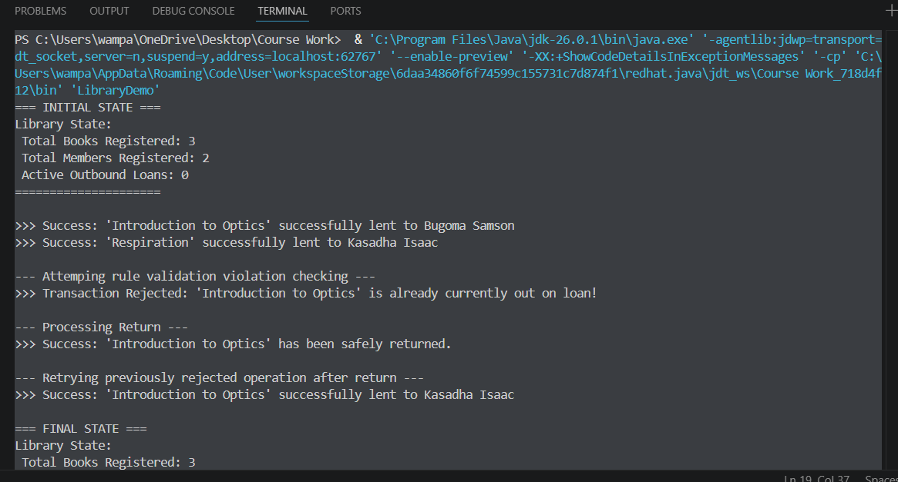
(i) Distinguishing Association, Aggregation, and Composition
- Association: Represents a general structural relationship where objects interact but exist independently with no implied lifecycle dependencies. In this system, Loan is an associative entity connecting a Member and a Book.
- Aggregation: A loose "has-a" part-whole relationship where the parts can survive after the whole is destroyed. This is used for Library containing Books or Members; if the library building shuts down completely, those physical items and individuals still persist independently.
- Composition: A strict, strong ownership "has-a" relationship where the lifetime of the child objects depends completely on the lifecycle of the parent container. For instance, if Loan objects are instantiated inside an invoice management object, destroying that parent records container instantly wipes out those transaction logs.
(ii) Explanation of Multiplicity “1
The multiplicity “1..*” explicitly signifies "One to Many" (meaning a minimum structural instance count of 1, up to an infinite maximum capacity bounds marker).
- Example from this Diagram: The target structural endpoint relationship pointing from Library down towards Book or Member. It notes that a functional Library object register context requires at least 1 or more active books/members initialized inside its collection arrays to make real tracking operational transactions possible.
Question two
Java implementation code for shapes
InvalidShapeException.java
* Custom Exception thrown when an invalid shape dimension
* or a non-positive resize factor is detected.
*/
public class InvalidShapeException extends Exception {
public InvalidShapeException(String message) {
super(message);
}
}
Shape.java
/**
* Abstract class representing a geometric shape.
*/
public abstract class Shape {
protected String color = "white";
protected boolean filled;

public Shape() {
}

public Shape(String color, boolean filled) {
this.color = color;
this.filled = filled;
}

// Abstract methods to be overridden by subclasses
public abstract double getArea();
public abstract double getPerimeter();
public abstract void resize(double factor) throws InvalidShapeException;

@Override
public String toString() {
return "Shape[Color=" + color + ", Filled=" + filled + "]";
}
}
Circle.java
/**
* Concrete subclass representing a Circle.
*/
public class Circle extends Shape {
private double radius;

public Circle(double radius, String color, boolean filled) throws InvalidShapeException {
super(color, filled);
if (radius <= 0) {
throw new InvalidShapeException("Invalid Circle: Radius must be positive. Provided: " + radius);
}
this.radius = radius;
}

@Override
public double getArea() {
return Math.PI * radius * radius;
}

@Override
public double getPerimeter() {
return 2 * Math.PI * radius;
}

@Override
public void resize(double factor) throws InvalidShapeException {
if (factor <= 0) {
throw new InvalidShapeException("Resize error: Scale factor must be positive. Provided: " + factor);
}
this.radius *= factor;
}

@Override
public String toString() {
return "Circle[" + super.toString() + ", Radius=" + radius + "]";
}
}
Rectangle.java
/**
* Concrete subclass representing a Rectangle.
*/
public class Rectangle extends Shape {
private double width;
private double height;

public Rectangle(double width, double height, String color, boolean filled) throws InvalidShapeException {
super(color, filled);
if (width <= 0 || height <= 0) {
throw new InvalidShapeException("Invalid Rectangle: Dimensions must be positive. Provided Width: "
+ width + ", Height: " + height);
}
this.width = width;
this.height = height;
}

@Override
public double getArea() {
return width * height;
}

@Override
public double getPerimeter() {
return 2 * (width + height);
}

@Override
public void resize(double factor) throws InvalidShapeException {
if (factor <= 0) {
throw new InvalidShapeException("Resize error: Scale factor must be positive. Provided: " + factor);
}
this.width *= factor;
this.height *= factor;
}

@Override
public String toString() {
return "Rectangle[" + super.toString() + ", Width=" + width + ", Height=" + height + "]";
}
}
Triangle.java
/**
* Concrete subclass representing a Triangle.
*/
public class Triangle extends Shape {
private double side1;
private double side2;
private double side3;

public Triangle(double side1, double side2, double side3, String color, boolean filled) throws InvalidShapeException {
super(color, filled);

// Validation 1: Positive Sides
if (side1 <= 0 || side2 <= 0 || side3 <= 0) {
throw new InvalidShapeException("Invalid Triangle: All side lengths must be positive.");
}

// Validation 2: Triangle Inequality Theorem
if ((side1 + side2 <= side3) || (side1 + side3 <= side2) || (side2 + side3 <= side1)) {
throw new InvalidShapeException("Invalid Triangle: Given sides violate the triangle inequality theorem.");
}

this.side1 = side1;
this.side2 = side2;
this.side3 = side3;
}

@Override
public double getArea() {
// Heron's Formula for Area of Triangle
double s = getPerimeter() / 2;
return Math.sqrt(s * (s - side1) * (s - side2) * (s - side3));
}

@Override
public double getPerimeter() {
return side1 + side2 + side3;
}

@Override
public void resize(double factor) throws InvalidShapeException {
if (factor <= 0) {
throw new InvalidShapeException("Resize error: Scale factor must be positive. Provided: " + factor);
}
this.side1 *= factor;
this.side2 *= factor;
this.side3 *= factor;
}

@Override
public String toString() {
return "Triangle[" + super.toString() + ", Side1=" + side1 + ", Side2=" + side2 + ", Side3=" + side3 + "]";
}
}
ShapeDemo.java
/**
* Main Driver Class executing calculations and catching errors.
*/
public class ShapeDemo {

// Method to display area through dynamic binding
public static void printAreas(Shape[] shapes) {
System.out.println("\n--- Displaying Areas via Superclass Polymorphic Reference ---");
for (Shape s : shapes) {
if (s != null) {
System.out.printf("Shape Class: %-10s | Total Calculated Area: %7.2f%n",
s.getClass().getSimpleName(), s.getArea());
}
}
}

// Method to find and return the shape with the largest area
public static Shape largest(Shape[] shapes) {
if (shapes == null || shapes.length == 0) return null;

Shape largestShape = shapes[0];
for (int i = 1; i < shapes.length; i++) {
if (shapes[i] != null && shapes[i].getArea() > largestShape.getArea()) {
largestShape = shapes[i];
}
}
return largestShape;
}

public static void main(String[] args) {
Shape[] shapeArray = new Shape[3];

System.out.println("====== VALID INSTANTIATIONS ======");
try {
shapeArray[0] = new Circle(5.0, "Red", true);
shapeArray[1] = new Rectangle(4.0, 6.0, "Blue", false);
shapeArray[2] = new Triangle(3.0, 4.0, 5.0, "Green", true);
System.out.println("Successfully instantiated Circle, Rectangle, and Triangle.");
} catch (InvalidShapeException e) {
System.out.println("Unexpected Error: " + e.getMessage());
}

// Polymorphic Dynamic Binding Area Output
printAreas(shapeArray);

// Find and Display the Largest Shape
Shape massive = largest(shapeArray);
System.out.println("\n--- Largest Shape Evaluation ---");
System.out.println("The largest shape is: " + massive);
if (massive != null) {
System.out.printf("Max Area Value: %.2f%n", massive.getArea());
}

// Demonstration of standard resize execution
System.out.println("\n====== RESIZE TESTING ======");
try {
System.out.println("Original state: " + shapeArray[0]);
shapeArray[0].resize(2.0); // Double dimensions
System.out.println("After resizing by factor of 2.0: " + shapeArray[0]);
System.out.printf("New calculated area: %.2f%n", shapeArray[0].getArea());
} catch (InvalidShapeException e) {
System.out.println("Error: " + e.getMessage());
}

System.out.println("\n====== EXCEPTION HANDLING TESTING ======");

// Test 1: Instantiating an invalid triangle (Violates Triangle Inequality)
try {
System.out.println("Attempting to create illegal triangle with sides (1, 2, 10)...");
Shape badTriangle = new Triangle(1.0, 2.0, 10.0, "Purple", false);
} catch (InvalidShapeException e) {
System.out.println("CAUGHT EXCEPTION SUCCESSFULLY: " + e.getMessage());
}

// Test 2: Testing a non-positive resize factor execution
try {
System.out.println("\nAttempting to resize the rectangle using an invalid factor (-0.5)...");
shapeArray[1].resize(-0.5);
} catch (InvalidShapeException e) {
System.out.println("CAUGHT EXCEPTION SUCCESSFULLY: " + e.getMessage());
}
}
}
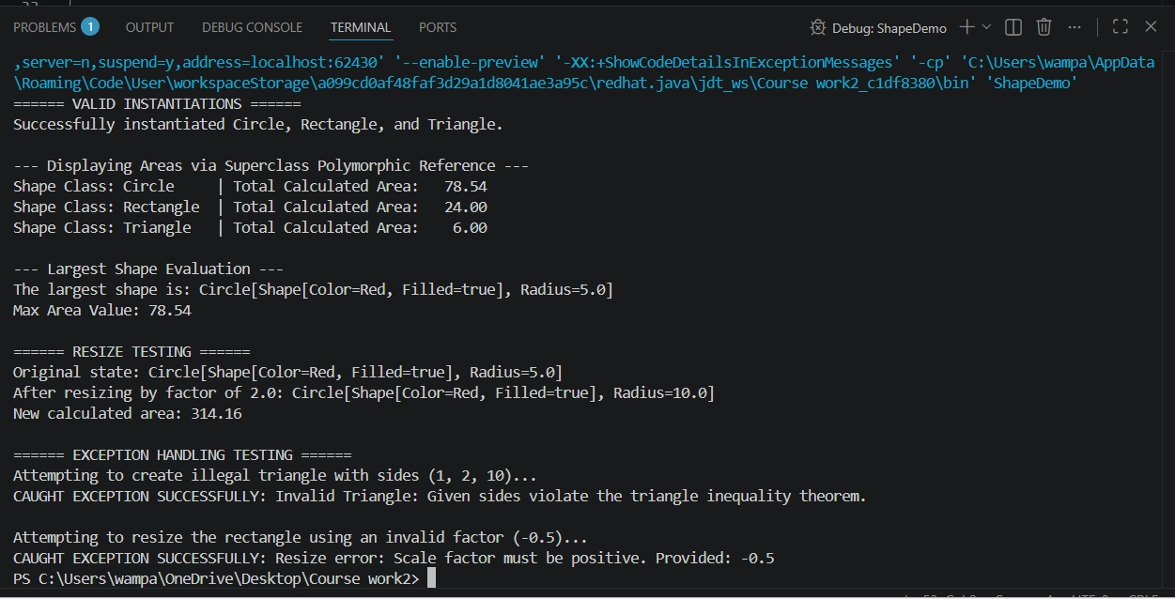

4. Theory & Concepts Analysis
Custom Exception Decision (Checked vs. Unchecked)
- Choice: InvalidShapeException was implemented as a Checked Exception by extending the base java Exception class.
- Justification: Checked exceptions are used for recoverable conditions where a program should anticipate potential input failures. Invalid dimensions (such as mismatched side lengths entered by a user) are a predictable runtime occurrence. Making it a checked exception forces developers to write explicit try-catch safety blocks, preventing unexpected program crashes during execution.
Dynamic Binding (Polymorphism)
Dynamic binding means that the Java Virtual Machine (JVM) determines which method implementation to call at runtime based on the actual object type, rather than the compile-time reference type.
Abstract Classes Analysis
- Why Shape is declared abstract: Shape is an abstract concept. A generic "shape" does not have a physical form, meaning it is impossible to compute its area or perimeter without knowing the specific geometry (e.g., Circle or Rectangle). Declaring it abstract allows us to define a shared template and common methods for all sub-items without providing dummy implementations.
- What happens if you attempt to use new Shape(): If you attempt to instantiate it directly (Shape s = new Shape();), the Java compiler will throw a compilation error: "Shape is abstract; cannot be instantiated". This acts as a safeguard to ensure that incomplete abstract structures cannot be created in memory.
QUESTION ONEa)
UML DIAGREAM FOR LIBRARY SYSTEM
